Providing first rate education in music & drama for over
100 years

Established in 1904 the Leinster School of Music & Drama has now passed its centenary year. Its long-standing tradition as both a centre for learning and examining is stronger than ever.

Experienced and dedicated teachers provide excellent tuition to pupils of all ages and levels. The emphasis is on learning through enjoyment, and while exams are encouraged they are not compulsory.

Students past and present are prominent performers both at national and international level, with many appearing at The National Concert Hall and venues throughout Ireland, and many others employed by orchestras and opera companies around the globe. Many of the current teaching staff are also firmly established in the performance arena. This experience, combined with their depth of teaching knowledge enhances the unique learning experience offered by the School.

"She beckoned to him with her finger like one preparing a certificate in pianoforte...at the Leinster School of Music.”
(Samuel Beckett)

- €30 application fee required with application. This will be deducted from term three fees only. Cash not accepted.

- Fees must be paid in advance of the beginning of each term and are non-refundable.

- Lessons missed by students will not be made up

- Students are advised to attend Theory or Harmony classes.

- Lessons are given on a weekly basis between 9am and 9pm

- Lessons are aimed towards the individual’s needs, whether for pleasure or working towards LSMD examinations.

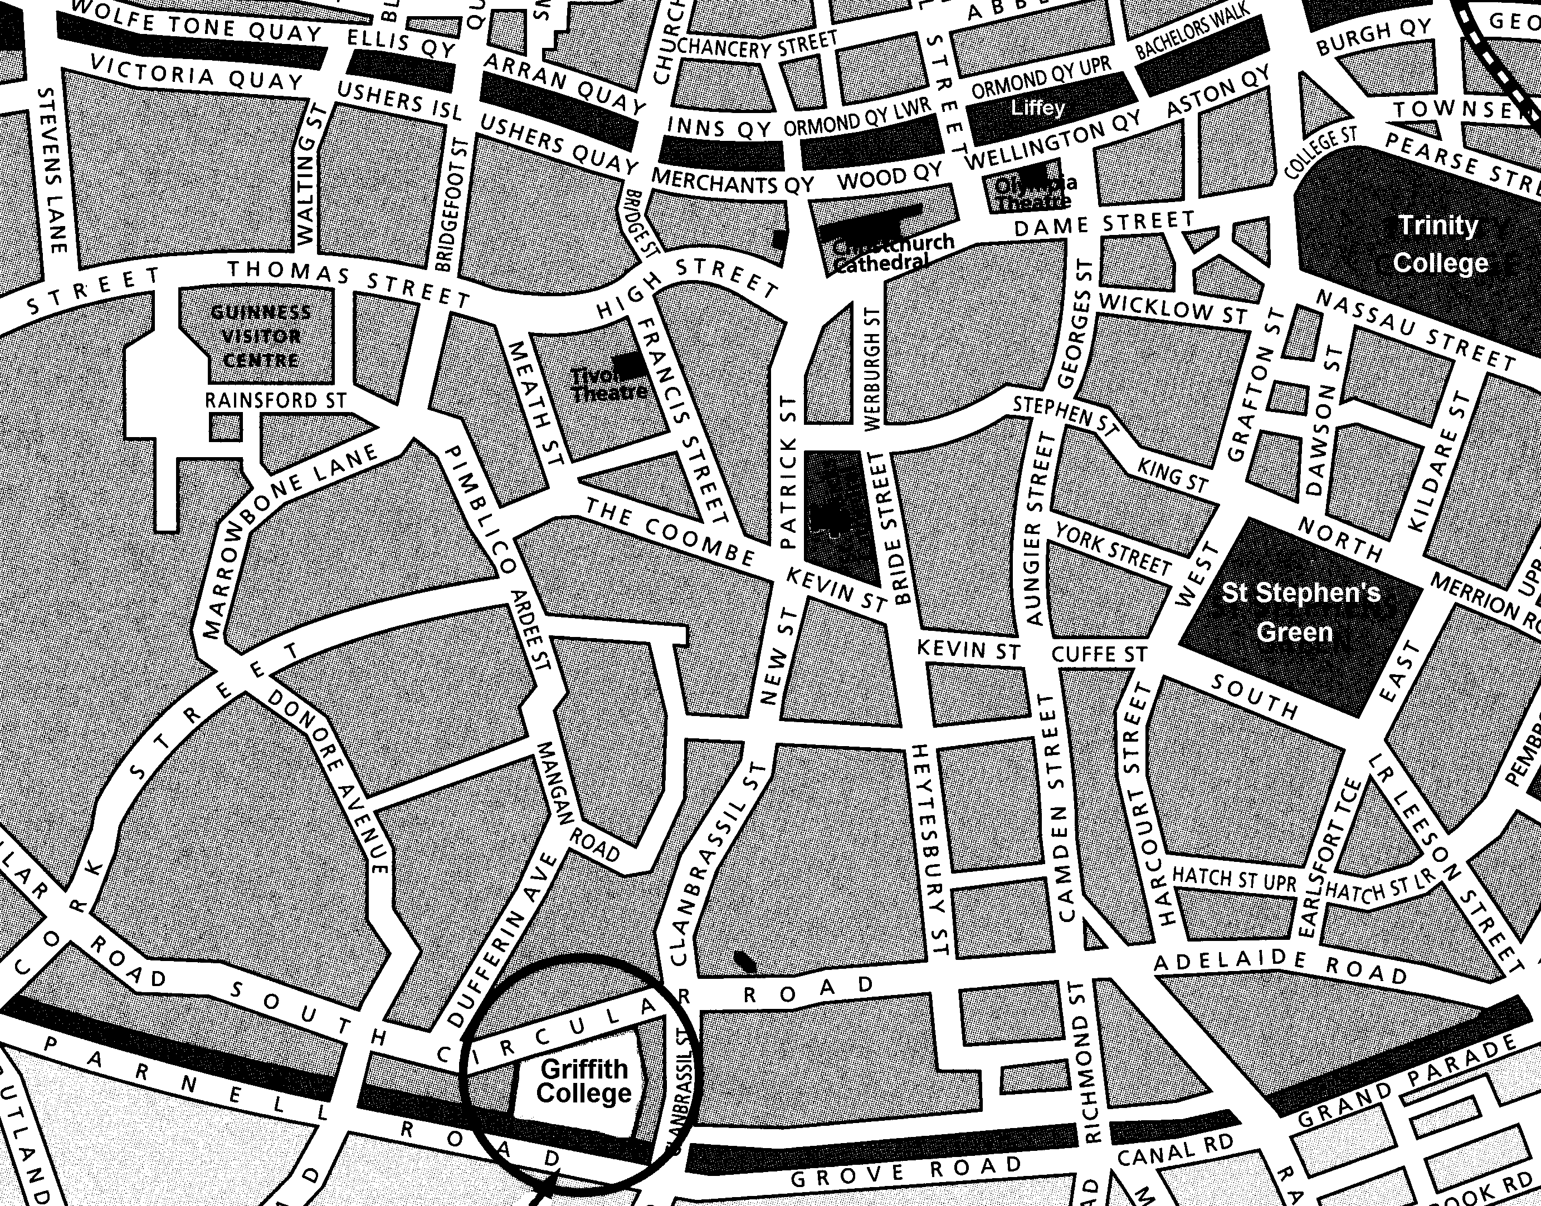

Local bus routes:
16, 16A, 9, 49, 54A, 122.

Luas Green Line:
The Harcourt Street stop is a 15 minute walk from campus.
Application Form 2014- 2015


The Leinster
School of
Music & Drama

Established 1904
MUSIC
Griffith College Dublin
South Circular Road
Dublin 8
Tel 01 - 4150 467
Fax 01 - 4549 265
leinster.school@gcd.ie
www.gcd.ie/lsmd

Piano | Singing
Catriona Grimes | Dr Veronica Dunne
Sarah Lane | Alan Leech
Claire McDonagh | Toni Martin
Gloria Mulhall | Miriam Mulrooney
Florence Ryan | Kathryn Smith
Guitar
Marc Collopy
Conal Rae | Vocal Coaching  Jeannie Reddin
Recorder
Marc Collopy | Clarinet / Sax/Flute
 | Mervyn Sayers
Composition / Harmony /
Theory / Sight-singing
Sarah Lane | Violin
Conal Rae | Sarah Lane
Gloria Mulhall | Gloria Mulhall
Music & Drama Prices

Standard rate (10 week term for all)
½ hour individual lessons €244 per term
1 hour individual lessons €488 per term

Advanced rate (Up to grade 10)
½ hour individual lessons €299 per term
1 hour individual lessons €598 per term

Group Lessons
Guitar,Piano,Keyboard,Recorder €170 per term

Composition / Harmony / Theory / Sight-singing
½ hour individual lessons €244 per term
Group theory classes (up to Grade IV) €139 per term
Group theory classes (Grade V & over) €159 per term

Leinster Orchestra
Adults & children €94 per term

Drama & Communication

Speech & Drama
Solo Acting
Effective Communication
Voice Improvement
Public Speaking

Interview Preparation
Musical Theatre

Teachers
Anne Simpson
Toni Martin

Teacher training courses

Higher Diploma in Arts in Music Education (HETAC Level 8, 60 Credits)
Certificate in Music Teaching (40 Credits)
Certificate in Music Teaching (20 Credits)

Higher Diploma in Arts in Drama Education-(HETAC Level 8)
Certificate in Drama Teaching (40 Credits)
Certificate in Drama Performance (20 Credits)

Tuition fees charged per
term of 10 weeks
Term 1 commences 15 September 2014
Term 2 commences 24 November 2014
Term 3 commences 23 February 2015

€30 Application fee must be paid with form. This will be deducted from term Three fees.

Application Form

Subject ………………………………………..………………

Name ………………………………..………………………

Guardian ………………………………………………………..

Address ……………………………………...….……………..

……………………………………………………………………….

Date of birth ………………………………………………………..

Telephone ………………………………………………………..

Email …………………………………………..……………

Please give details of previous lessons (if any)

………………………………………………...……………………..

………………………………………………………………...……..

…………………………………………………………...…………..

Number of years studying ………………………………………..

Last examination taken ………………………………………..

Examining body ………………………………………..

Other relevant information ………………………………….…...

……………………………………………………...……………….

Please indicate (√) your availability below. The more times you are available the better chance you have of acquiring a place.

 | 9am | 10am | 11am | 12pm | 1pm | 2pm | 3pm | 4pm | 5pm | 6pm | 7pm | 8pm
Mon
Tues
Wed
Thur
Fri
Sat

Your application will be put on file and you will NOT be contacted until one of our teachers has a free space that matches your availability.
On confirmation of a place, fees must be paid in advance.

Signature: _____________________________________

Date: _____________________

