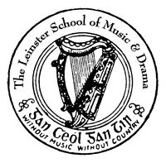

The Leinster School of Music & Drama

Certificate of Proficiency in Teaching

100 marks

June 2012

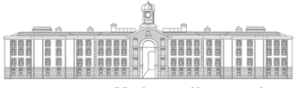
GRIFFTH COLLEGE DUBLIN

All three parts to be answered

Part 1. Rudiments (40 marks)

Answer five of the 6 sections in this section

- Rewrite the following extract as it would be played

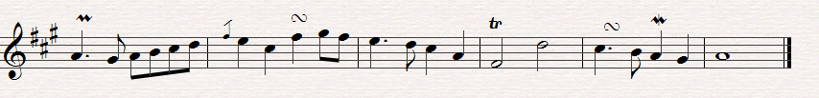

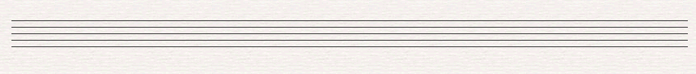

- Transpose this short extract down a minor 3rd.

- Identify the following intervals

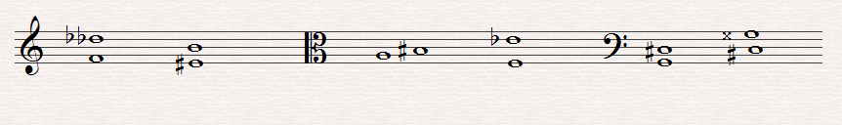
_________________________________________________________

- Describe fully each of these triads and state whether they are in root position, 1st or 2nd. Inversion

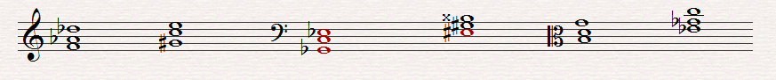
_______________________________________________________________

- Insert the time signature and add bar lines to the following extract.

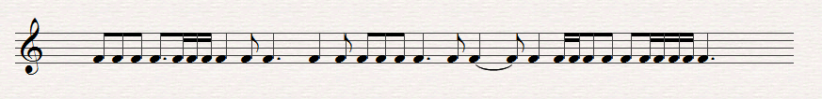

- Explain each of the following terms

(a) Attaca (d) Cantando

(b) Colla Voce (e) Giocoso

(c) Lacrimoso (f) Mancand

Part ii Analysis (30 Marks)

A (For Piano candidates)

Study this 3rd movement from Mozart’s Sonata in C KV 546 and answer all the questions below

- With reference to bar numbers outline the structure of this movement, including modulations.

- Outline the other possible forms for the third movement of a Sonata

- Describe the chords including position in bars 36 and 37

- Identify the cadence outlined in Bar 39

- Identify the Key between Bars 12 and 16

Part iii History (30 Marks)

Answer A or B. Include musical citations or examples to support or answer

A (1685 – 1800)

One question only to be answered

A1 Discuss the Brandenburg Concertos of Bach and their significance in the development of the concerto

Or

A2 Discuss the Operas of Mozart and their contribution to the development of this form of composition

B (1800 – 1900)

One question only to be answered

B1 “As a composer of the Symphony Beethoven stands supreme in the History of Music.” Discuss

Or

B2 Discus the piano music of either Schumann of Mendelssohn
